* Doubt : what do we mean after however it is desirable…

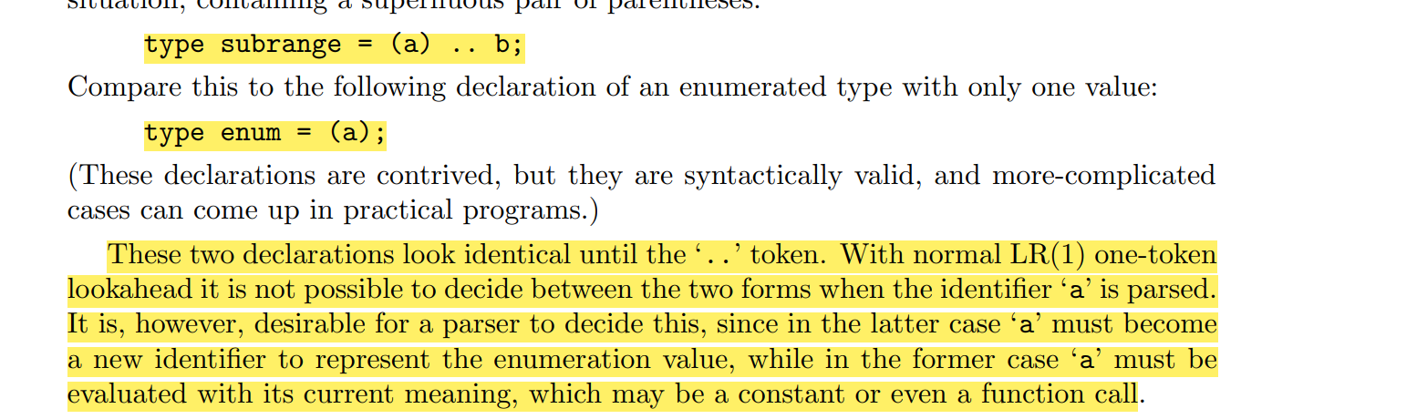

* Did not understood the problem with GLR parser

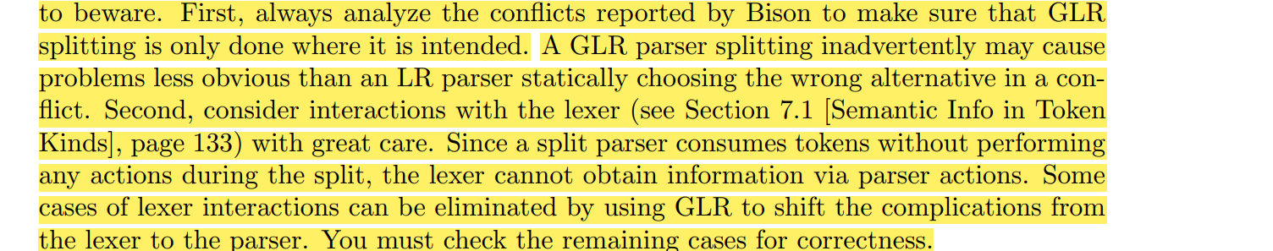

* Did not understood flagging sentence …

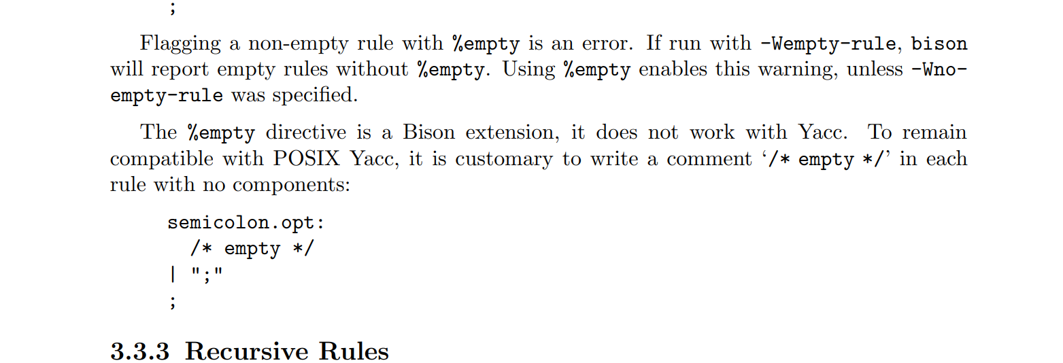

* Doubt in Internationalization

